**LGD WORK FOR PUJA PERMISSION**

URL- https://lgdirectory.gov.in/

**DEFINING ADMINISTRATIVE UNIT ENTITY**

1. **Entry of police station**:-

**Go to Department**🡪**Define Administrative Unit Entity**

**Administrative unit Level**🡪**Police Station**

**Parent level Administrative Unit Entity**🡪**Select the sub division**

**Administrative Unit Entity name🡪 Name of Police station (Avoid including PS or any other word)**

Click on “**Publish**” button. You will get the confirmation message of entry

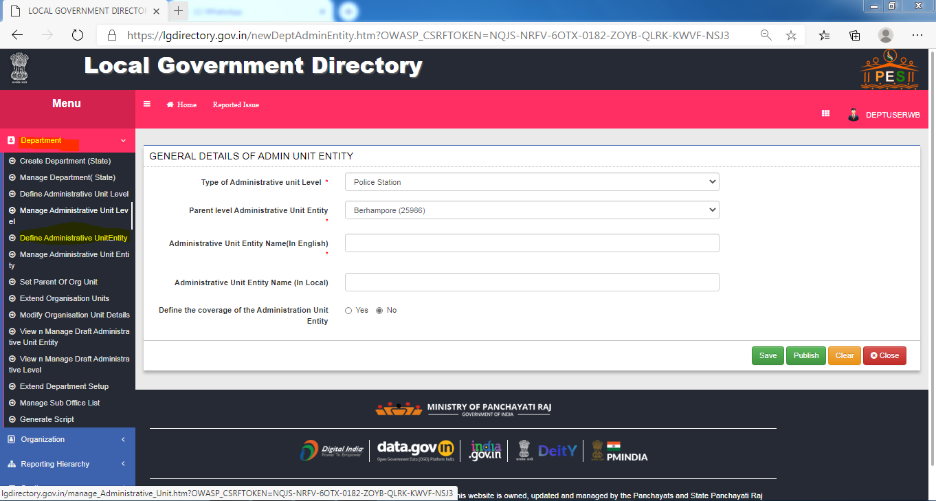

1. Set Parent of org unit- mapping between the department level
2. Home(police)-Mapping between District level Organisation to sub division

Mapping Between sub division level Organisation to Police station

1. Urban Development and Municipal affairs- Mapping between District level Organisation to sub division

Mapping Between sub division level Organisation to Minicipality

1. Panchayat and rural development- Mapping between District level Organisation to sub division

Mapping Between sub division level Organisation to Block

1. Fire brigade- Mapping between District level Organisation to sub division
2. West Bengal State Electricity Distribution Corporation- Mapping between District level Organisation to sub division

**MAPPPING BETWEEN DEPARTMENT LEVELS**

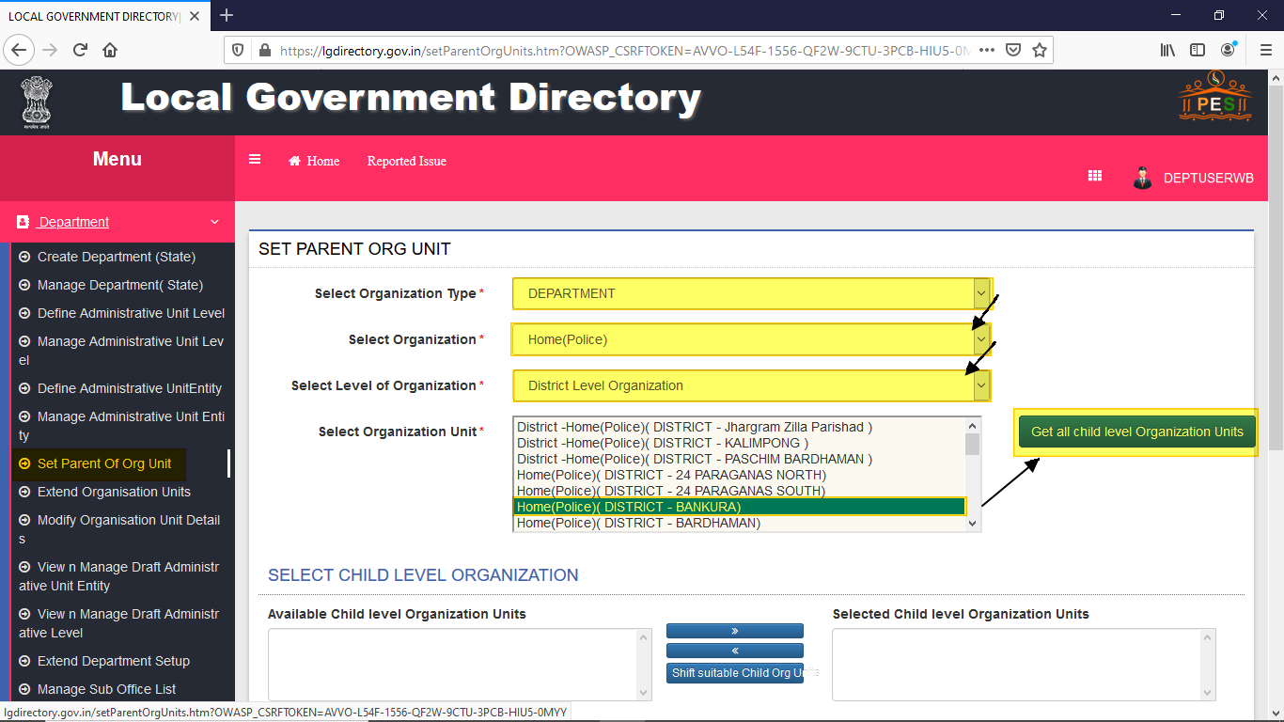

Click **“Get all child view organization units”.**

Select 🡪 **child** and **click right arrow button**.

Click **“save Mapping”.**

Then confirm the popup message.

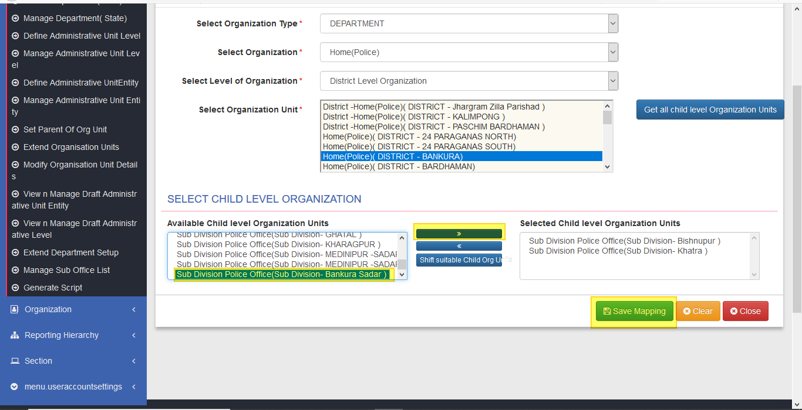

Select **Organization** **Type** 🡪**Department**

Select **Organization**🡪**Home (Police)**

Select Level of **Organization**: **Sub-Division Level Organization**

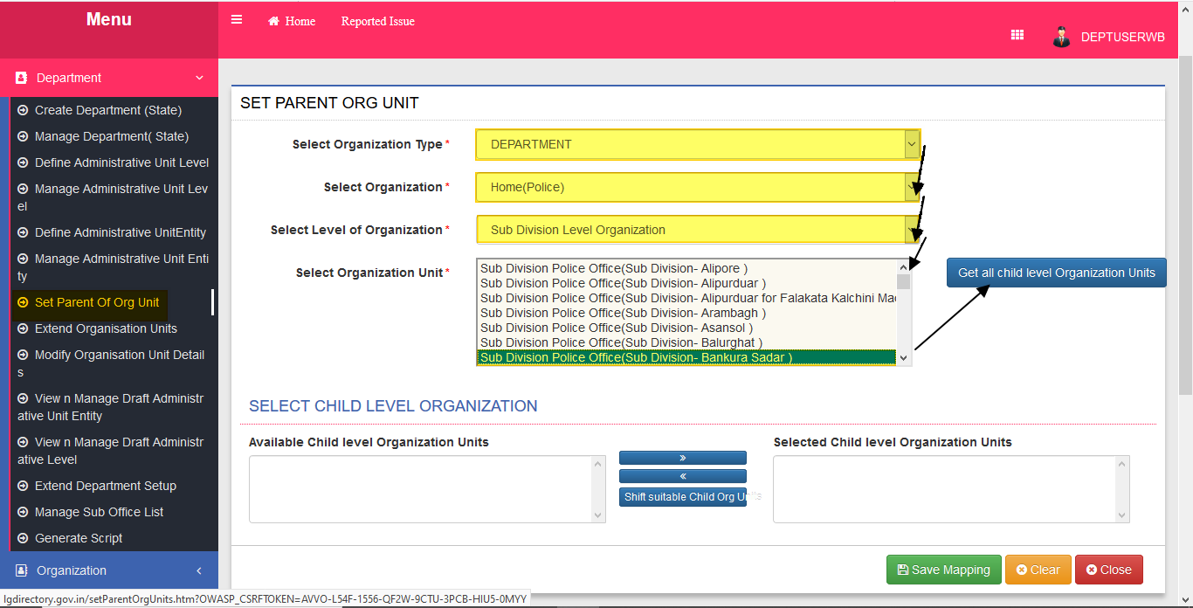

Click **“Get all child view organization units”.**

Select **child** and **click right arrow button**.

Click **“save Mapping”.**

Then confirm the popup message.

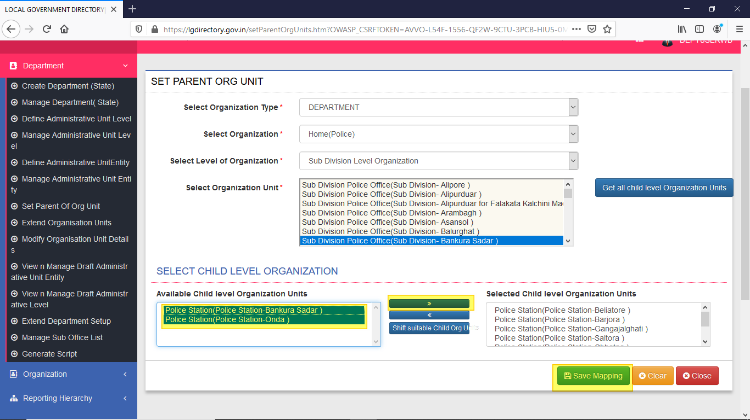

**REPEAT THIS PROCEDURE FOR OTHER ORGANIZATIONS.**

**FOR GENERATING SCRIPTS**

**FIRST LOGIN 🡪 GO TO GENERATE SCRIPT**

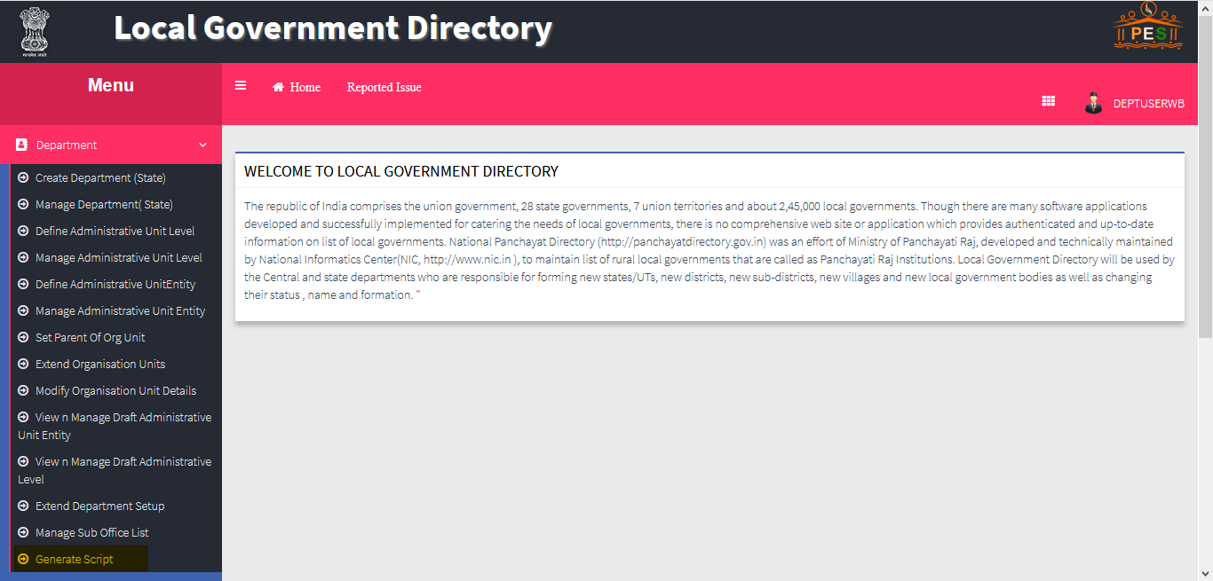

**INSERT SCRIPT**

**SELECT ORGANIZATION🡪WBSEDC (WEST BENGAL STATE ELECTRICITY DISTRIBUTION CORPORATION) OR ANY ORGANIZATION.**

**SCRIPT GENERRATION FOR 🡪 ORGANIZATION 🡪 GENERATE INSERT SCRIPT**

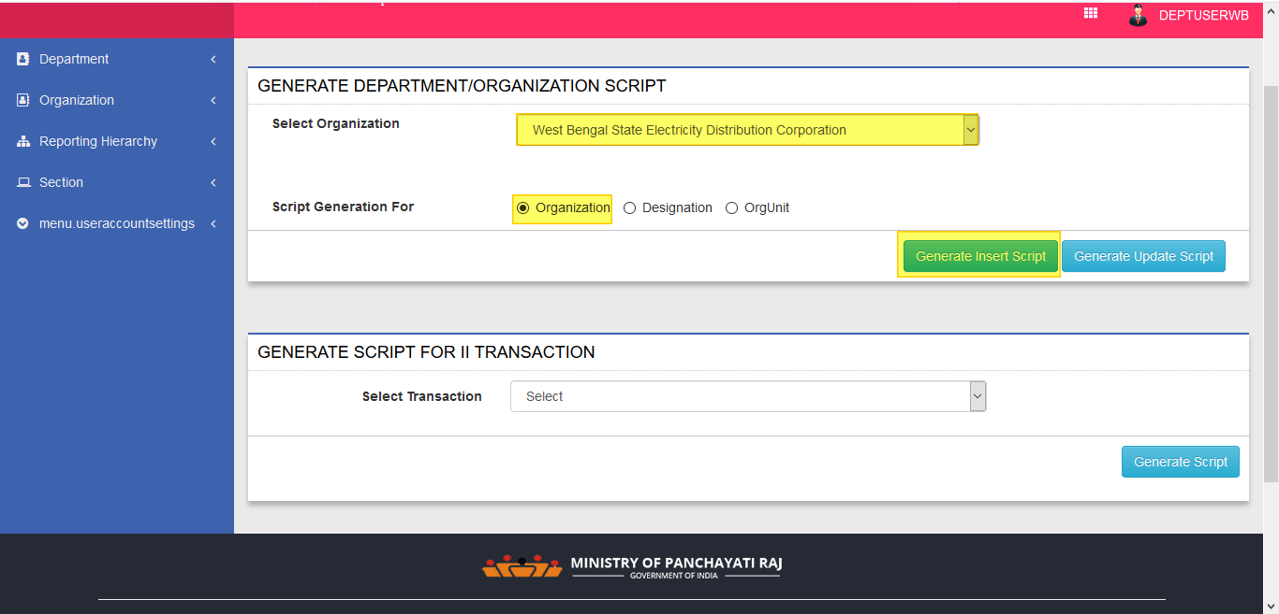

**CONFIRM THE POP UP MESSAGE BY SELECTING 🡪 YES**

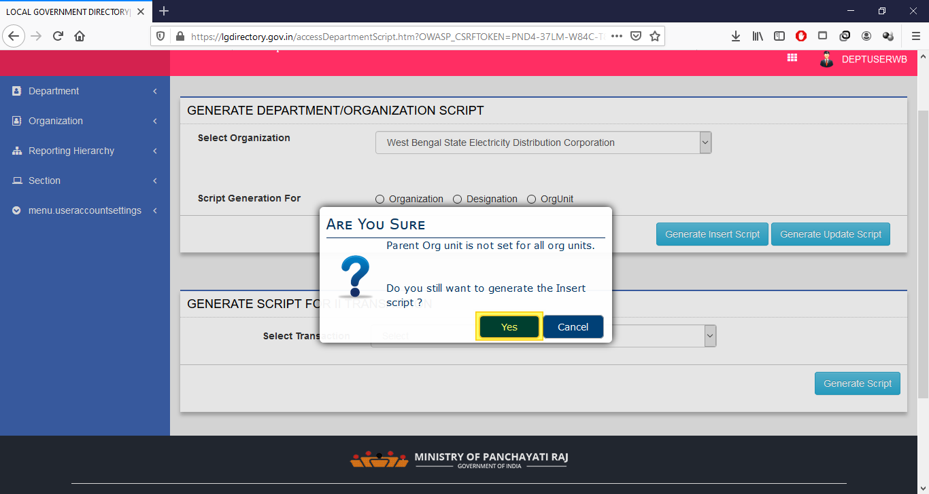

**A SUCCESSFULL INSERT SCRIPT GENERATION MESSAGE WILL POP UP 🡪 SELECT OK AND CONTINUE**

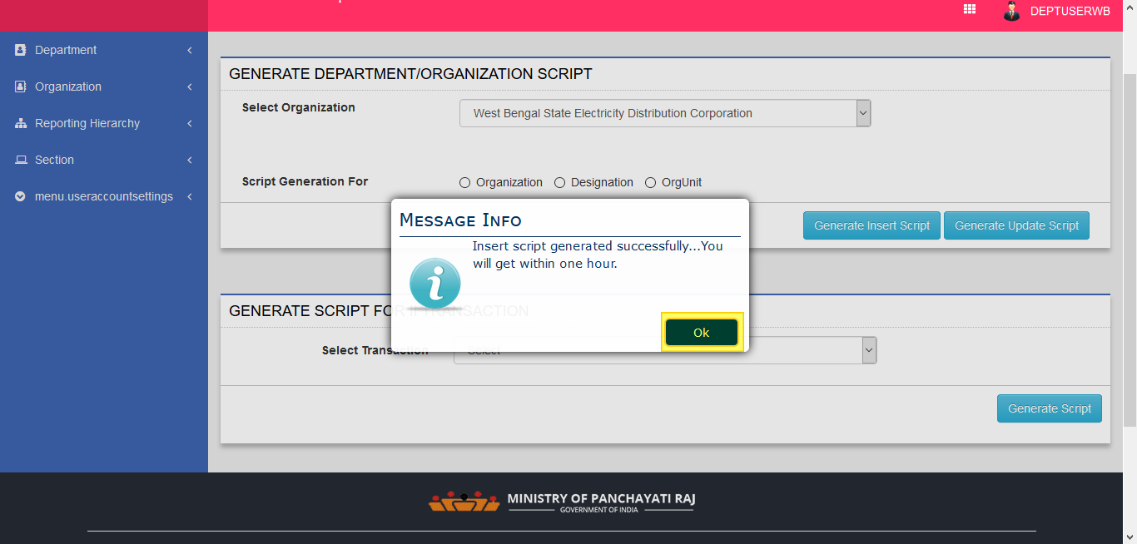

**UPDATE SCRIPT**

**SIMILARLY SELECT ORGANIZATION🡪WBSEDC (WEST BENGAL STATE ELECTRICITY DISTRIBUTION CORPORATION) OR ANY ORGANIZATION.**

**SCRIPT GENERRATION FOR 🡪 ORGANIZATION 🡪 GENERATE UPDATE SCRIPT**

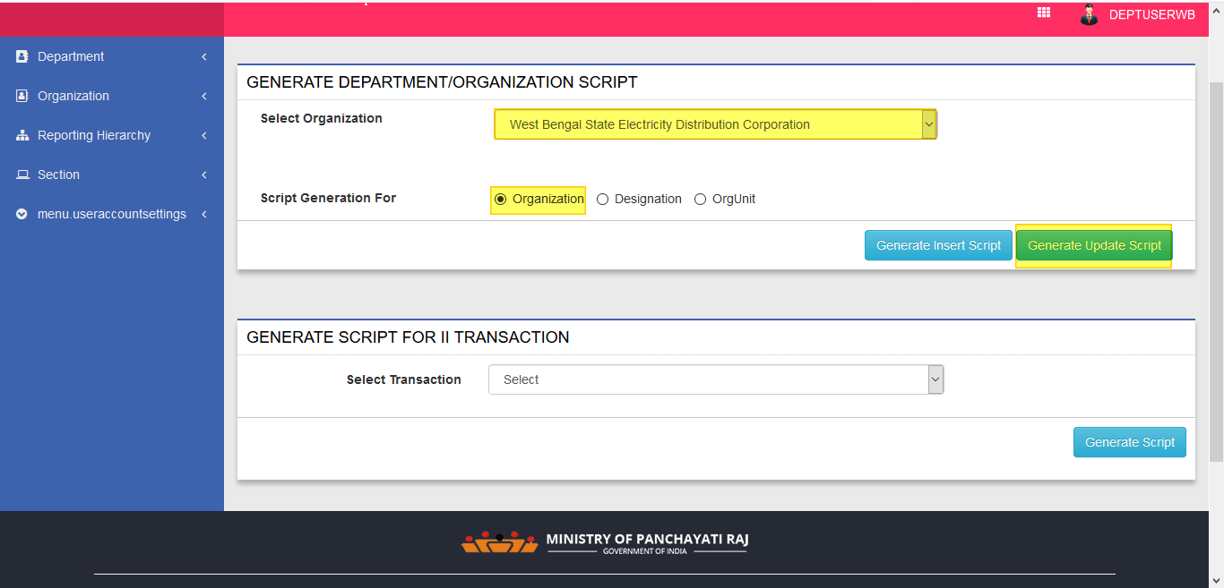

**A SUCCESSFULL UPDATE SCRIPT GENERATION MESSAGE WILL POP UP 🡪 SELECT OK AND CONTINUE**

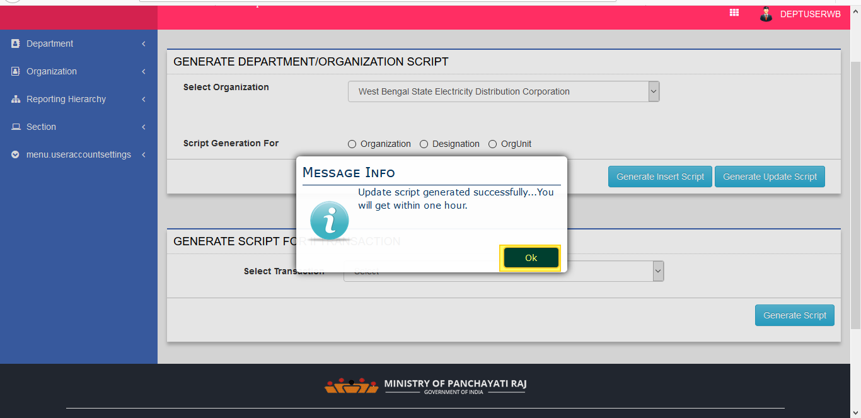

**INSERT SCRIPT**

**NOW SELECT DEPARTMENT🡪WBSEDC (WEST BENGAL STATE ELECTRICITY DISTRIBUTION CORPORATION) OR ANY ORANIZATION.**

**SCRIPT GENERRATION FOR 🡪 DESIGNATION 🡪 GENERATE INSERT SCRIPT**

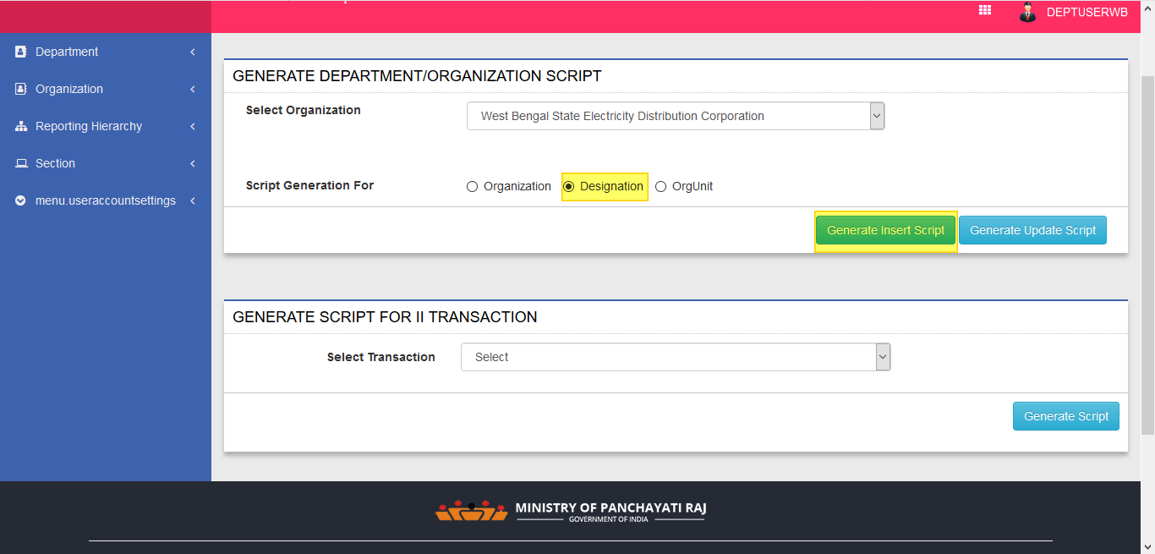

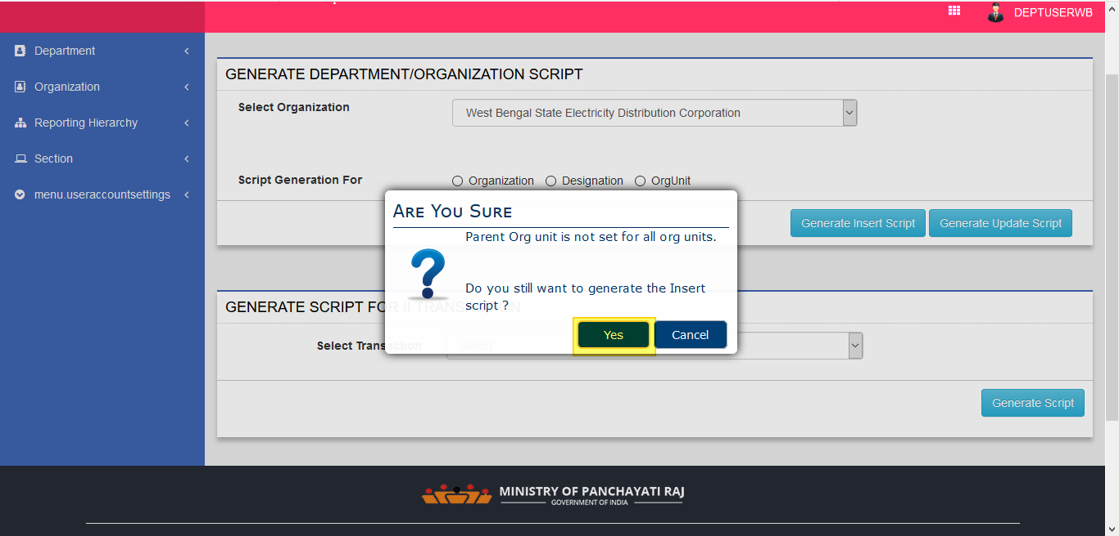

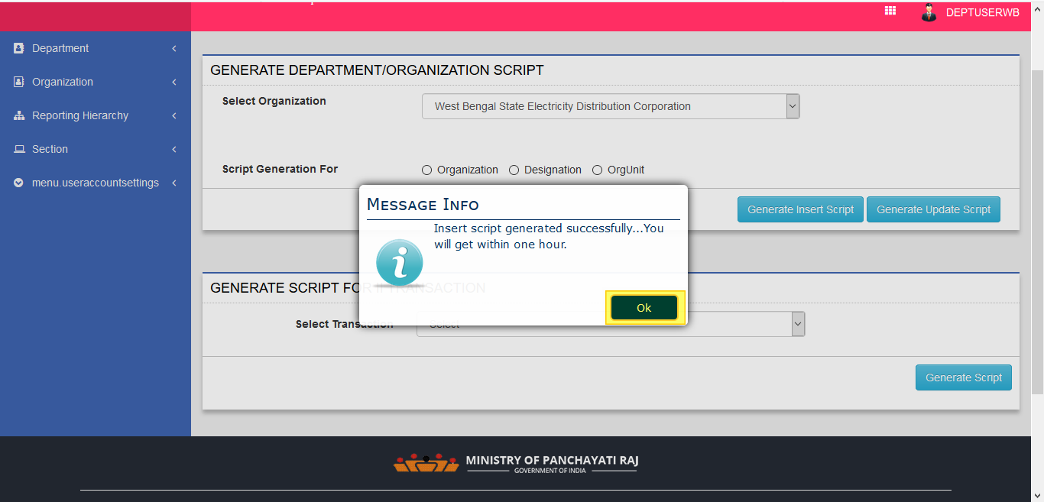

**UPDATE SCRIPT**

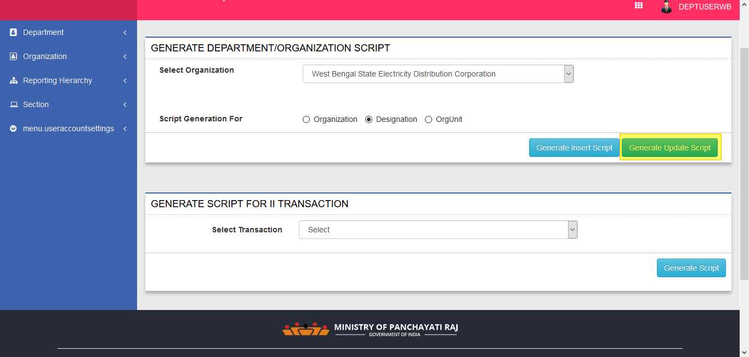

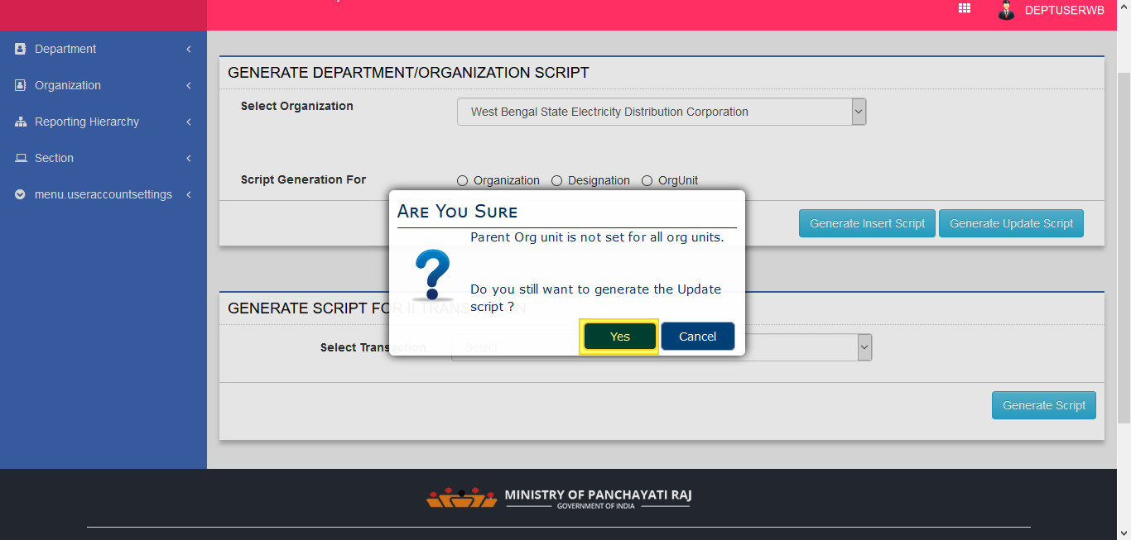



**🡪NOW DO THIS FOR REMAINING**

**🡪ORG UNIT AS ABOVE FIRST INSERT SCRIPT🡪THEN UPDATE SCRIPT**